Alex Copeland
Hypixel Skyblock DA Project
Research Question
The goal of this project is using our dataset, can we predict a player’s net worth based on their skills and Skyblock Level? This study focuses on Hypixel Skyblock, a popular Minecraft server that mixes sandbox gameplay with RPG-style mechanics. Players explore, gather resources, and trade in a large player-driven economy. Each player builds their own island and can visit others to collect materials, fight enemies, or complete challenges that affect how they progress and earn money.
Player progress is mainly tracked through their skills and Skyblock Level. Skills include Combat, Farming, Fishing, Mining, Foraging, Enchanting, and Alchemy. Most of these skills go up to level 60, except Fishing and Alchemy, which have lower limits. Each skill represents how experienced a player is in that part of the game, for example, higher Combat levels help defeat enemies faster, and higher Farming or Mining levels make collecting materials more efficient. Skyblock Level summarizes a player’s overall activity and achievements, usually ranging between 0 and 500. For this project, the dataset only includes players above level 75 to focus on experienced players rather than beginners.
Because players can take many paths in Hypixel Skyblock. Combat, Farming, Mining, or trading, their net worth can vary a lot. The goal of this project is to see if a player’s skills and level can predict how wealthy they are. This not only shows how progress and wealth are connected but also provides a hands-on example of using supervised learning in a game setting.
Why This Research is Useful
Predicting net worth helps players understand how efficiently they’re progressing in the game. Players spend coins to buy better tools, armor, or items to help them earn more later. If two players both have a Skyblock Level of 120 but one has a much higher predicted net worth, the other can adjust their strategy maybe focusing more on farming, mining, or combat to earn more value over time.
Luck also plays a role in Skyblock’s economy. Rare drops from bosses or special events can boost a player’s wealth significantly. Although luck can’t be predicted directly, higher skill levels usually lead to better chances at these rare items. Players with high Combat levels can fight bosses faster and more often, while higher Farming or Mining levels help gather resources more efficiently. Using skills and Skyblock Level as predictors captures these general trends in wealth growth without needing to track every random event.
This project is also useful because it applies real data science methods like regression and feature analysis to a real-world gaming system. The same ideas could be used in other games or systems where progression, skills, and resources are connected to performance or success.

Predictor and Target Variables
The target variable for this project is net worth, which represents the total value of a player’s coins, items, and assets. net worth gives a more complete view of success than coins alone, since players often reinvest coins to make more money later. Predicting net worth helps show how a player’s effort and skill translate into actual economic results in the game.
The predictor variables are the seven skills (Combat, Farming, Fishing, Mining, Foraging, Enchanting, and Alchemy) along with the Skyblock Level. Each skill improves how effectively a player performs specific actions like collecting materials, crafting, or fighting, and Skyblock Level sums up a player’s long-term progress. Using these predictors helps connect both detailed skill data and overall activity to a player’s total net worth.
Data Source
The dataset includes 100 individual player accounts collected manually from different in-game lobbies, ensuring accurate and consistent information. It contains nine variables: seven skills, Skyblock Level, and net worth. There are no missing values, so the data is clean and ready to use.
The dataset represents a snapshot of active players at one point in time. It does not include extra details like total playtime, dungeon completions, or pets, which might also influence net worth. These could be added in future research to make the predictions even more accurate.
The data includes players with a wide range of levels and wealth, from newer mid-level players to extremely rich ones. This variety makes it a great dataset for supervised learning since it provides a balanced mix of experience and economic standing.
Data Description
The dataset contains 100 players with nine variables in total. Skill levels range from beginner to maxed-out, showing a wide variety of play styles. All players have Skyblock Levels of 76 or higher, meaning they’re active and experienced in the game. net worth varies a lot across players, reflecting the mix of skill, effort, and luck involved. This data captures both the detailed parts of gameplay and overall progress. It’s ideal for supervised learning because models can find patterns between player progression and wealth while still accounting for randomness in gameplay.
Models
To predict net worth, this study uses Decision Trees and K-Nearest Neighbors (K-NN). A Decision Tree works by splitting the data into smaller groups based on skill levels or player stats. Each split helps show which skills or levels are the most important for predicting net worth. This model is easy to understand and clearly shows which features have the biggest impact on player wealth.
K-Nearest Neighbors (K-NN) predicts a player’s net worth by finding other players with similar skill and level values and averaging their net worth. It works well when the relationship between skills and net worth is smooth and continuous instead of following strict cutoffs.
Using both models gives a good balance. Decision Trees explain what’s most important in the data, while K-NN focuses more on accuracy by comparing players to others like them. Together, they help show how player progression and skills connect to overall wealth.
Checking for Missing Values
Phase 2 of this project focuses on preparing the dataset for modeling and evaluating how well the Decision Tree and K-Nearest Neighbors (K-NN) models can predict a player's net worth based on their Skyblock Level and skill values. Since my dataset was collected manually and contained clean, consistent entries, the data cleaning process was straightforward but still required some key steps to make the values usable in a predictive model. The first task was checking for missing values. After loading the dataset, I verified that all 100 player observations contained valid entries for Skyblock Level, each of the seven skills, and net worth. Because there were no missing values, I did not need to remove any rows. This allowed me to focus on transforming the variables so they would work properly in the models.

Data Transformations and Cleaning
The main transformation required in this dataset involved the net worth column. The data I collected used text values like “1.8B” or “182.5M,” which are typical in Hypixel Skyblock but cannot be used directly in mathematical models. To fix this, I converted all net worth values into numeric values measured in billions. For example, a value like “182.5M” became 0.1825, and “1.8B” became 1.8. This allowed the models to treat net worth as a continuous numeric variable. Next, I removed the Username column. Usernames do not represent numeric features and cannot be used to predict wealth, so removing them helps streamline the model. The remaining eight predictors, Skyblock Level, Combat, Farming, Fishing, Mining, Foraging, Enchanting, and Alchemy were already numeric and needed no additional processing. This meant I could use them directly as inputs for my Decision Tree and K-NN models.

Decision Tree Model Evaluation
Once the data was prepared, I began evaluating the models. For the Decision Tree, I used an 80/20 train–test split and tested depths from 1 through 10. The goal was to find the tree that gave the lowest sum of squared errors (SSE) on the test set. Shallow trees had extremely high SSE values because they could not capture the complexity of the relationship between skills, levels, and net worth. As the depth increased, the SSE dropped, especially between depths 4 and 5. The lowest test SSE occurred at depth 6, with a value of about 376.6. This meant that a depth-6 tree provided the best balance between accuracy and generalization. Trees deeper than 6 began to overfit, causing SSE to rise again. Based on this performance, max_depth = 6 was chosen as the best model. When fitting this model on the entire dataset, the tree produced a total SSE of about 98.86, which reflects the variation that still cannot be predicted from skills alone.

Decision Tree Variable Importance
To understand which skills were most important, I examined the feature importance values produced by the Decision Tree. Skyblock Level stood out as the most important variable, contributing about 60% of the predictive power. This makes sense because Skyblock Level represents overall progression and unlocks many money-making methods. Foraging and Fishing were also significant, with importance values around 20% and 14%, suggesting that gathering-related skills play a meaningful role in predicting wealth. Skills like Combat, Mining, Alchemy, and Enchanting had very low importance values, which indicates they might not be as directly tied to earning money. These importance scores help explain how the model makes predictions and support the idea that progression and resource collection tend to be the main drivers of net worth.
Decision Tree Output

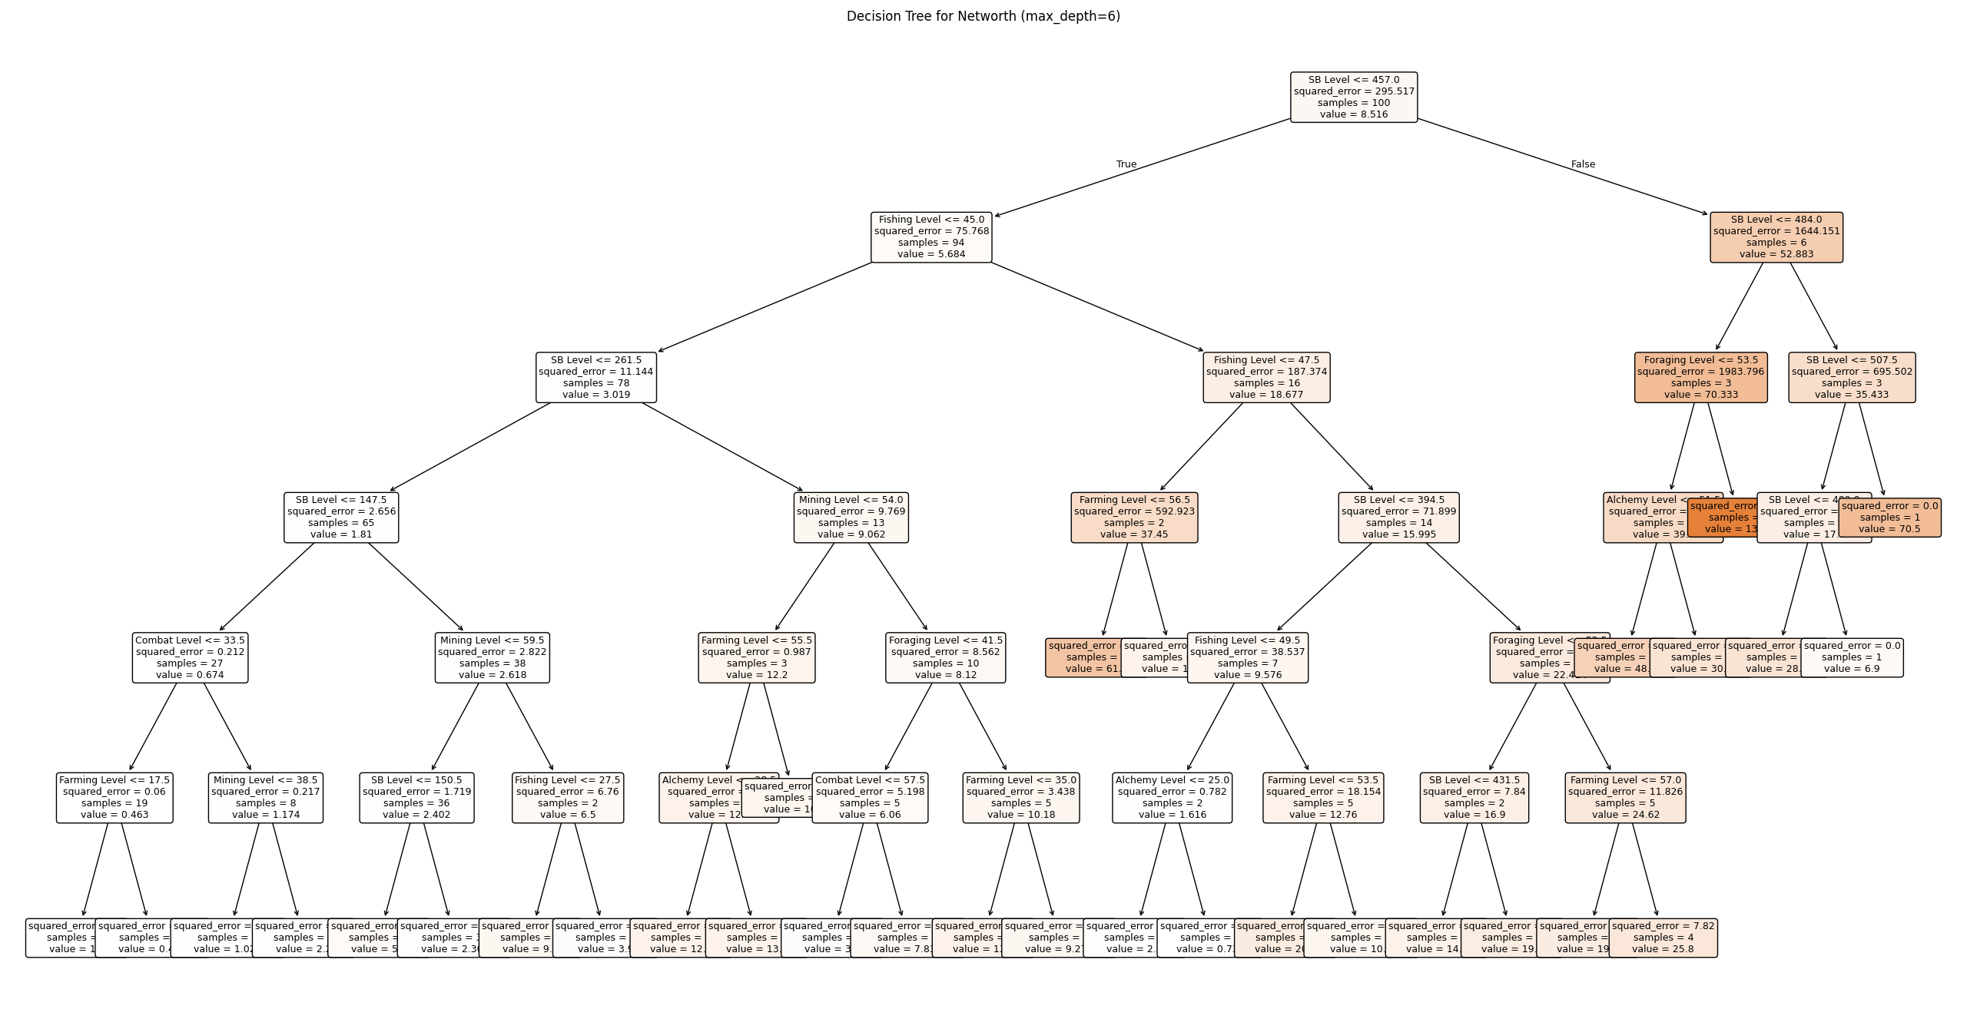
The Decision Tree gives a visual breakdown of how the model predicts a player's net worth based on their Skyblock Level and skill values, and it helps show which variables matter the most when the model is actually making splits. At the very top of the tree, the first split is on Skyblock Level, which confirms what the feature importance scores already suggested, that SB Level is the strongest overall predictor of net worth. Players with lower Skyblock Levels tend to fall on the left side of the tree, where the predicted values are much smaller, usually under 5 billion coins. As the tree continues branching, you can see that the model uses other skills like Fishing Level, Foraging Level, Mining Level, and occasionally Farming Level to refine these predictions. The model’s splits get more specific as you move downward, dividing players into smaller and smaller groups based on differences in these skills. For example, mid-level players with moderate Fishing Levels might get separated from players with very low Fishing Levels, which leads to different predicted net worth values. On the right side of the tree, where Skyblock Levels are much higher, net worth values rise sharply, eventually reaching extremely rich players with predicted values above 50 billion. You can also see that once you reach this side of the tree, skills like Foraging or Alchemy only show up as secondary checks, mostly fine-tuning predictions rather than making big changes. One interesting thing about this structure is that some skills hardly appear at all, Combat, for example, only shows up in a few minor branches, and Enchanting is almost never used. This matches the feature importance results and reinforces the idea that progression and gathering skills matter more than combat-related stats when it comes to wealth. Overall, the tree helps show how the model thinks: it first separates players based on their overall progression (SB Level), and then uses resource-related skills to estimate where their net worth likely falls. The visualization also makes it easy to see why a depth of 6 works well, because going deeper doesn't meaningfully improve predictions and mostly just adds branches that overfit small groups of players.

K-Nearest Neighbors (K-NN) Model Evaluation
For the K-NN model, I used Leave-One-Out Cross-Validation (LOOCV), where each player is treated as the test case once. I tested odd values of k from 1 to 19 and bandwidth values from 1 to 10 for the exponential weighting function. The goal was to find the combination that produced the lowest SSE. The best combination ended up being k = 19 and bandwidth = 10, meaning the model relied on a large number of neighbors and gentle distance weighting. However, even with its best configuration, the K-NN model performed poorly, with an SSE of more than 23,565. This is much higher than the Decision Tree SSE and shows that K-NN was unable to match players to others with similar wealth patterns. Players who appear similar in their skill values may still have wildly different net worths due to factors not included in the dataset, such as playtime, trading habits, rare drops, or profile age. Because of this, K-NN was not a reliable choice for this prediction task.

Model Performance Summary
In terms of model performance, the Decision Tree clearly outperformed the K-NN model. The depth 6 Decision Tree captured enough structure in the data to produce reasonably low SSE values while avoiding overfitting. Since SSE was the main criterion used to evaluate the models, the Decision Tree was chosen as the better model for predicting net worth based on the available data. The K-NN model, despite its flexibility, struggled due to the variability and noise in net worth values that cannot be explained purely by skill levels and progression.
Conclusions and Further Studies
I was somewhat surprised by how different the two models performed, especially considering they were both trained on the exact same skill values and Skyblock Level. I expected the Decision Tree to do well, but I didn’t think it would outperform K-NN by such a huge margin. The K-NN model had an extremely high SSE even at its best settings, which showed me that players with similar skill numbers don’t always have similar Net worth. This makes sense in hindsight, since Hypixel Skyblock is a game where a player's wealth can come from things the model can’t see, like rare drops, flipping items, farming efficiency, or just how long someone has played. So K-NN struggled because two players who look “close” in terms of Combat or Fishing Level might still be very far apart in actual wealth. On the other hand, the Decision Tree seemed to capture the general pattern pretty well. It made sense that Skyblock Level ended up being the main variable the model relied on because it represents a wider range of progression. For studies outside the scope of the project, I would like to look into models with deeper understanding of the game. I would like to have a model approach the game with knowledge of rare drops, how long someone has played, or maybe potentially tell players the most optimal way to progress throughout the game as they play.
Attribution and Code
I used OpenAI’s ChatGPT to help me with parts of this project, mainly with writing the Python code, understanding the stats, and helping me word things more clearly. I still ran all the models myself, looked at all the results, and made my own decisions about what they meant for the project. I used ChatGPT as a tool to learn and to help me work through the parts I’m not experienced with, not as a replacement for my own work. All source code can be found on my github (https://github.com/Alex-Copeland-5/DA-460-Project).

